1. 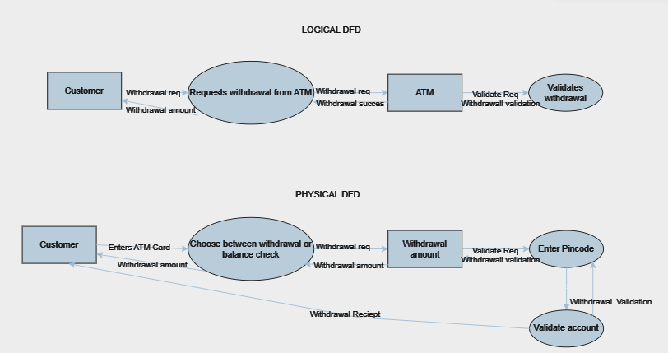CASH ENCHEQUE IN ATM SYSTEM
2. AIRPLANE TICKETING SYSTEM

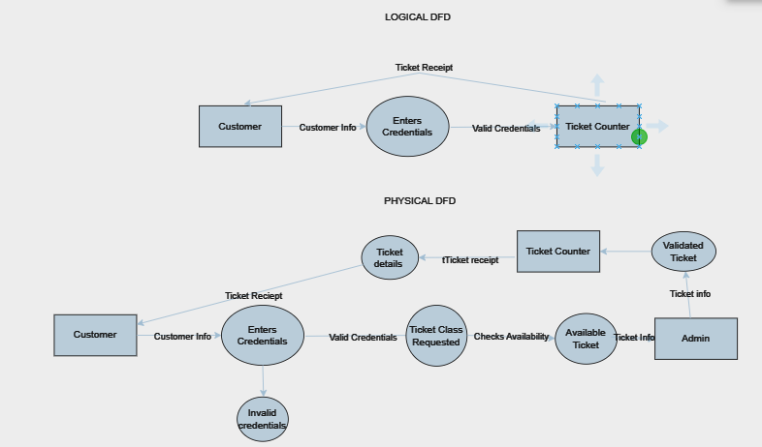

1. BOOK RESERVATION SYSTEM